Lab 4

COMP6035: Computer Security Principles



**Your Name**

Student #: R00201303

Date: 12.12.2021

Group: COMP1D-Y

# 

# PART 1 - Shift Substitution & Brute Force

# TASK 1.1:

Screenshot(s) and observations for decrypted task 1.2 instructions:

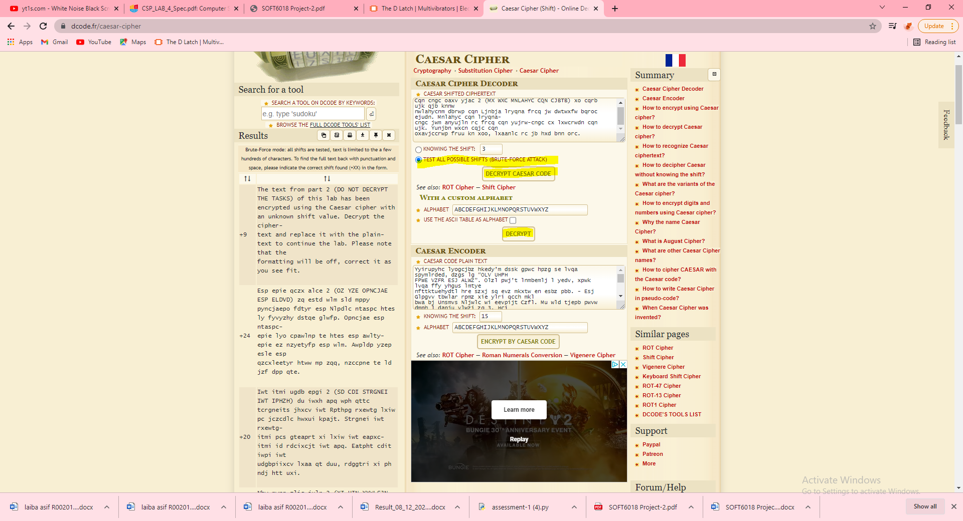

# TASK 1.2:

Screenshot(s) and observations for decrypted Part 2 instructions:

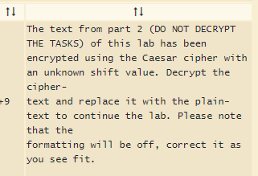

# PART 2 - Substitution and Frequency Analysis

# TASK 2.1:

Screenshot(s) and observations for this decrypted task:

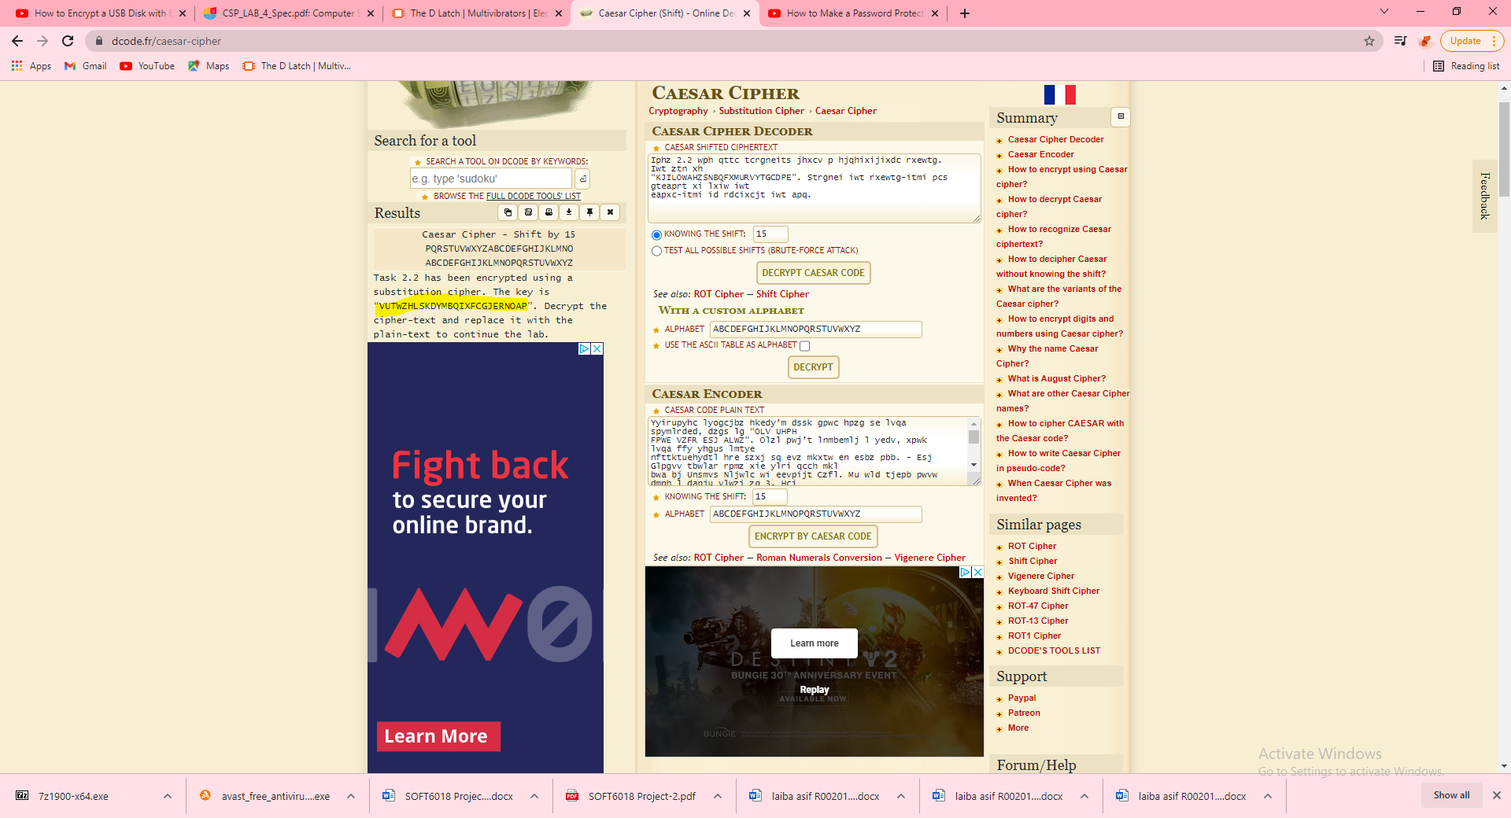 Key: “ VUTWZHLSKDYMBQIXFCGJERNOAP”

# TASK 2.2:

Screenshot(s) and observations for this decrypted task:

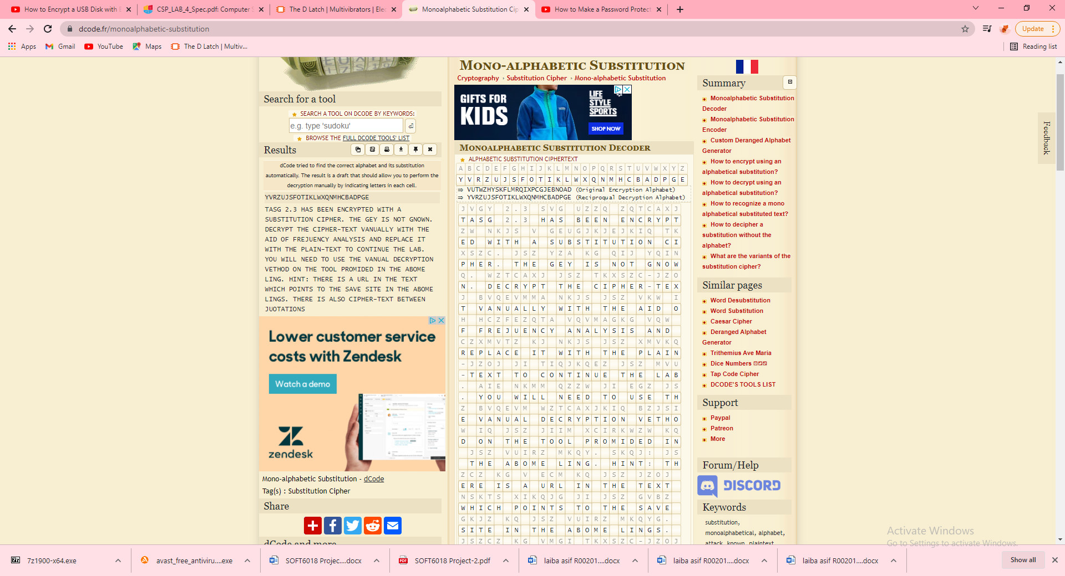

# TASK 2.3:

Screenshot(s) and observations for this decrypted task:

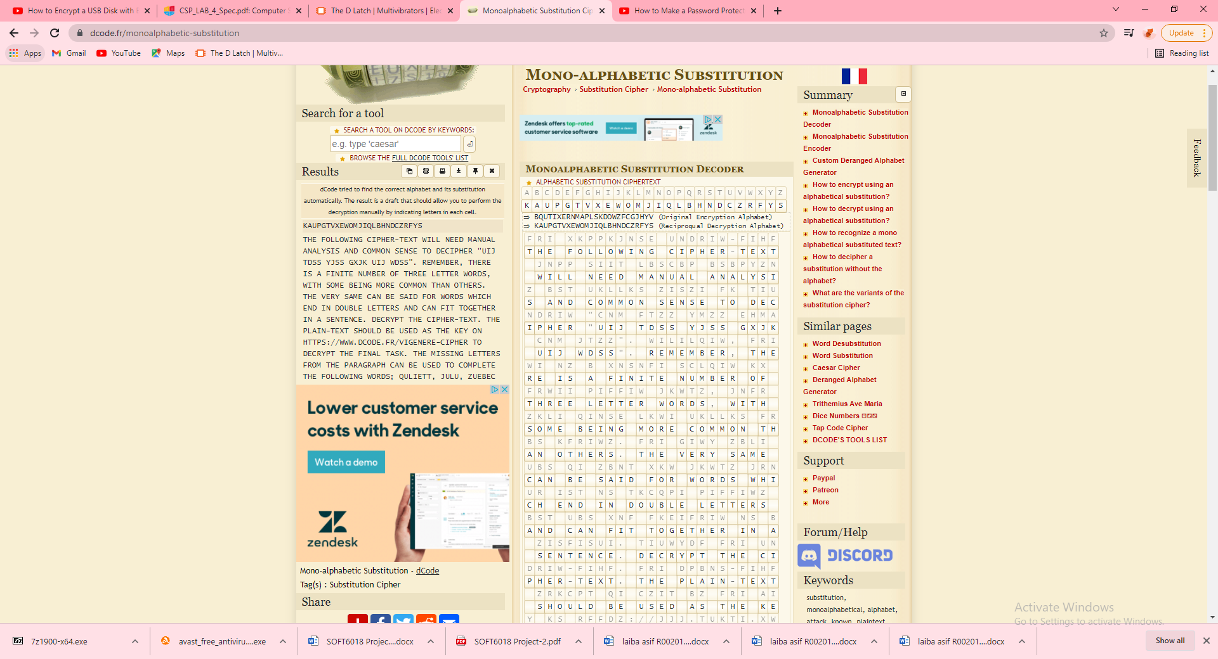 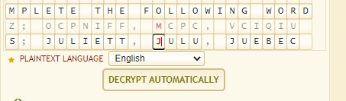

# TASK 2.4:

Screenshot(s) and observations for this decrypted task: 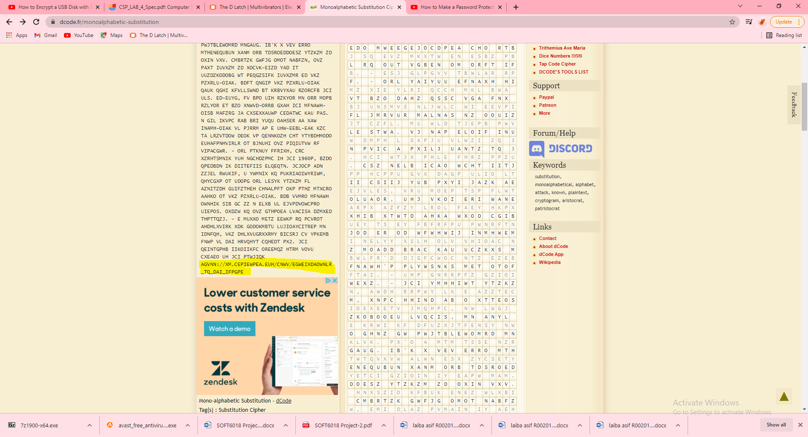

# PART 3 - Practical Encryption Tasks

Remember to submit the word, pdf, excel and zip files to Canvas along with your laboratory report.

# TASK 3.1:

Process for encrypting USB key screenshot(s) and observations: 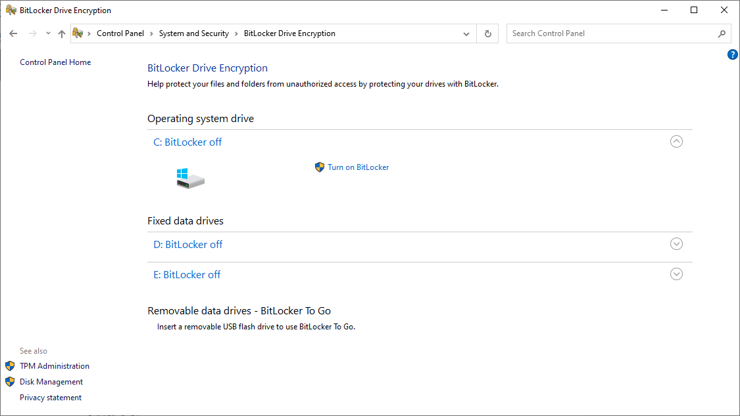 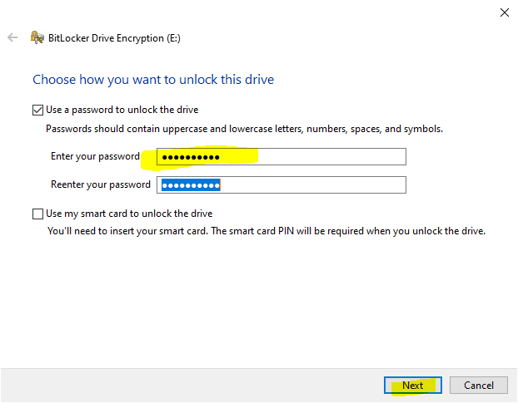 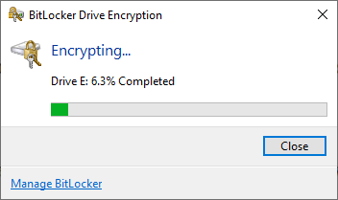 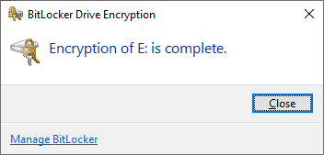 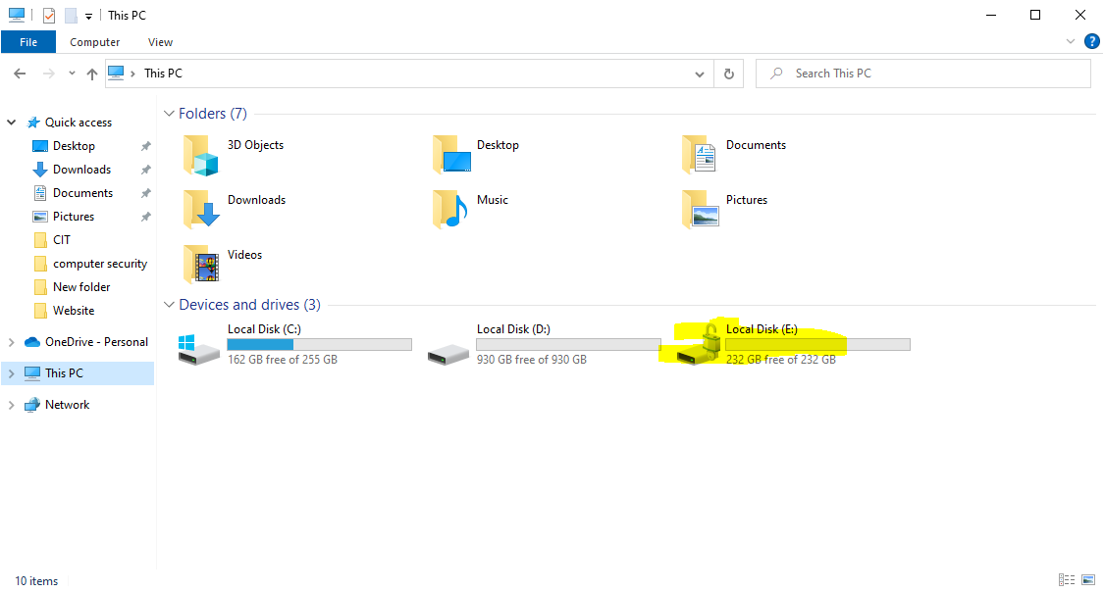

# TASK 3.2:

Encrypting word document screenshot(s) and observations: 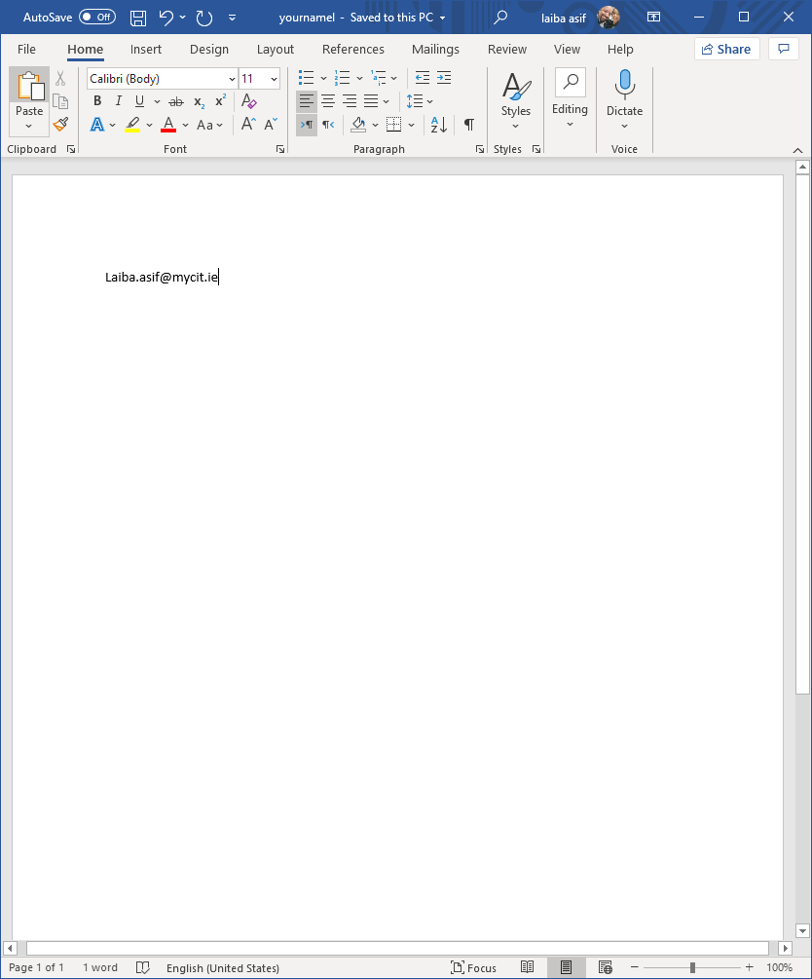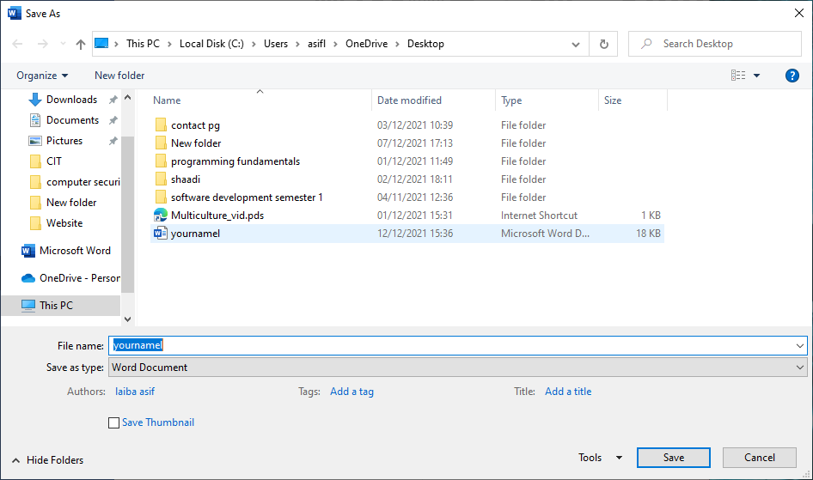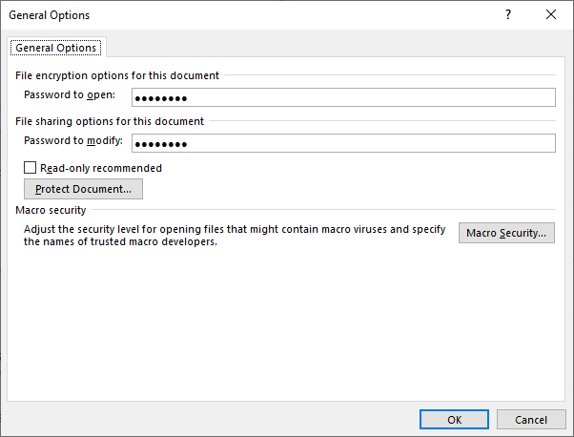 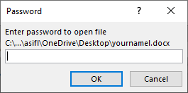

# TASK 3.3:

Encrypting pdf document screenshot(s) and observations: 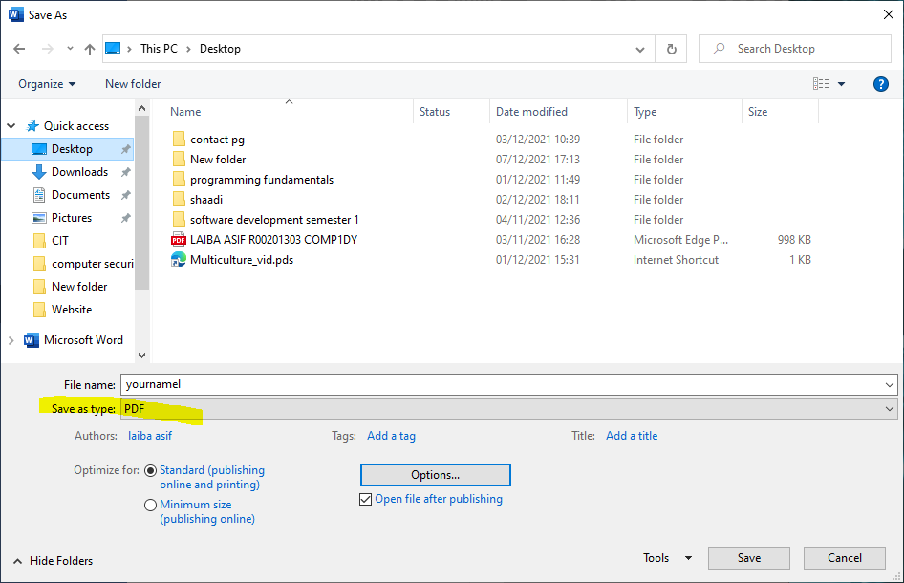 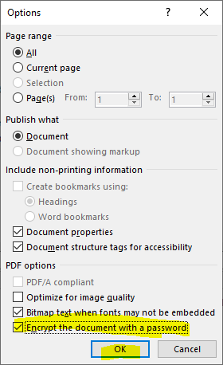 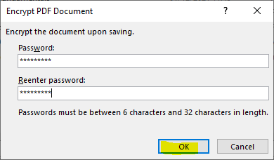

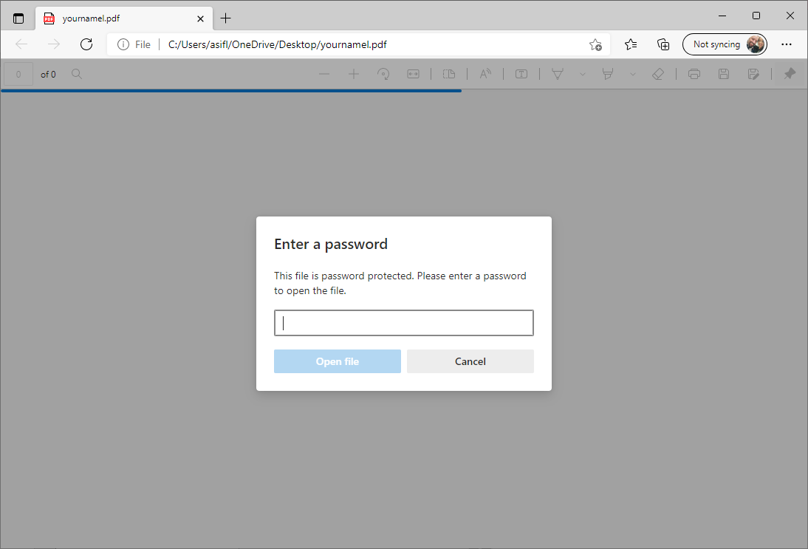

# TASK 3.4:

Encrypting excel document screenshot(s) and observations: 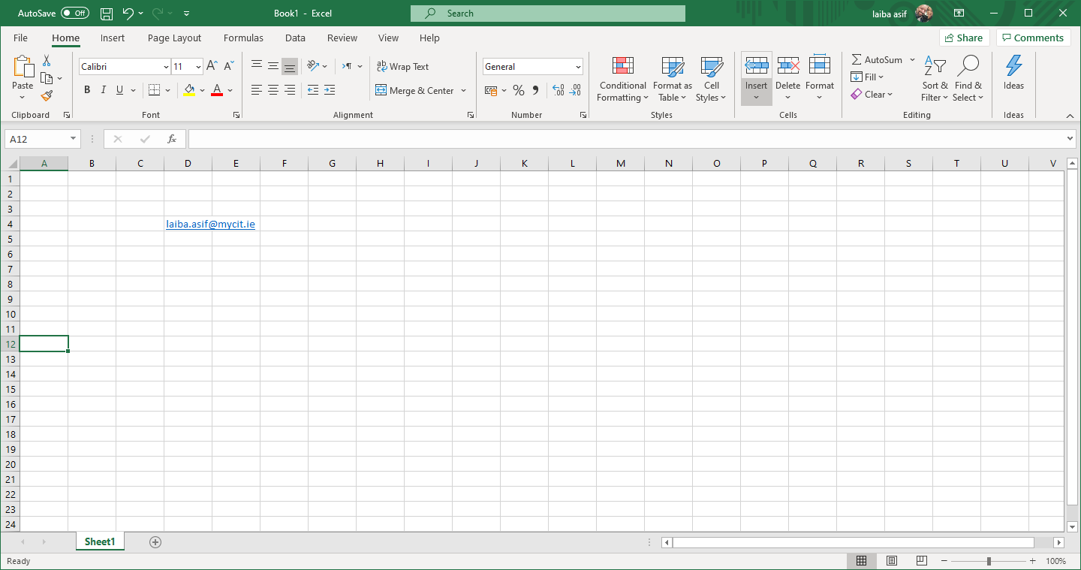 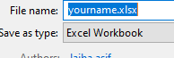

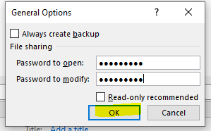 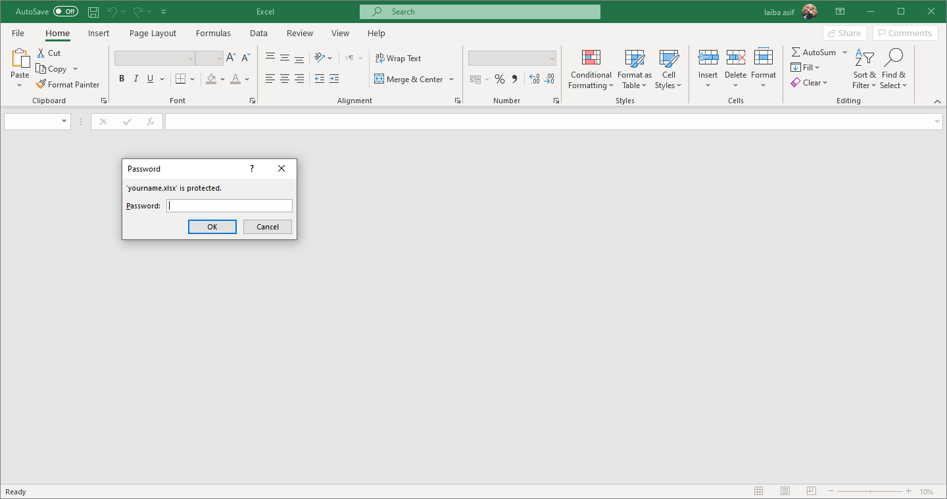

# TASK 3.5:

Encrypting notepad document screenshot(s) and observations:

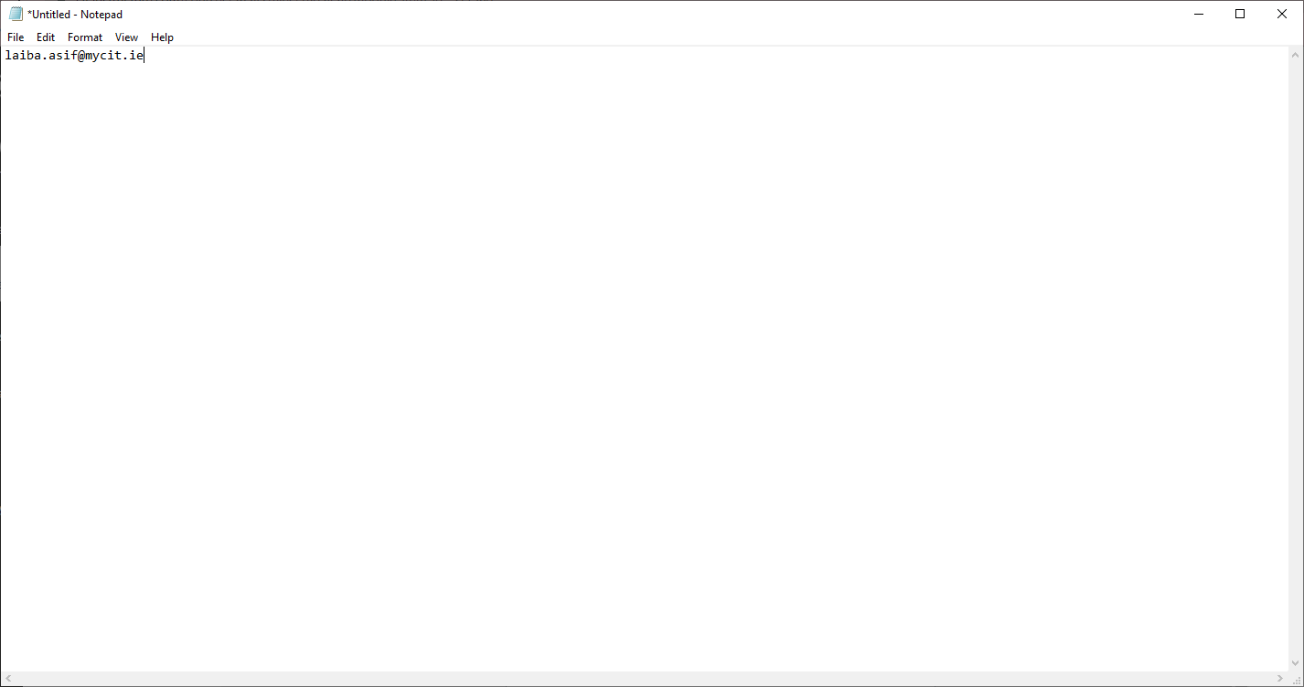 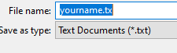  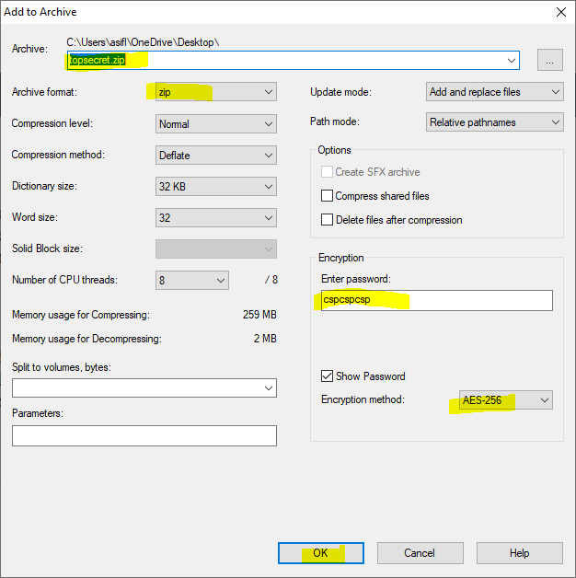 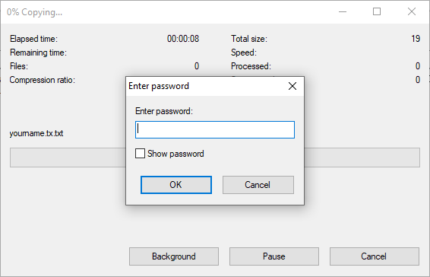

# TASK 3.6:

What CA issued the certificate for the <https://www.cit.ie> website and when will it expire?

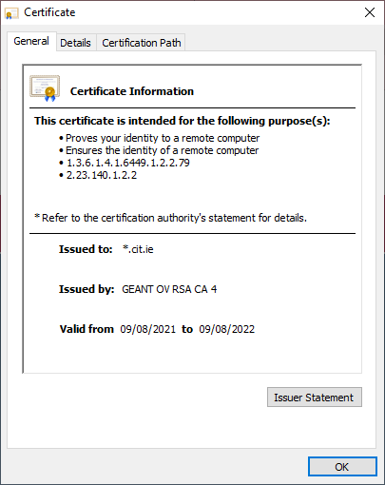

# Conclusion

Summarise what you have learned in the lab. This is an important and significant part of completing lab work.

The Caesar cipher determines which letter substitutes another by using a shift value. A shift value of 3 to the right, for example, would cause A to be replaced with D. This shift value serves as the encryption key for this procedure.

Substitution refers to the act of replacing one item with another. This often refers to a letter, number, or symbol being replaced with another letter, number, or symbol in the context of cryptography. The replacement letter, number, or symbol "shifts" or moves away from the original letter, number, or symbol in the relevant alphabet by a specified number of "shifts" or movements.